LAB 1
Defect log
ID | FILE | LINE | DESCRIPTION | SEVERITY
DEFECT 1 | tasks.py | 23 | add_task uses mutable default argument tags=[] — shared/mutated list leaks across calls | High
DEFECT 2 | Tasks.py | 48 | get_pending_tasks loops from index 1, skipping the first task (off-by-one) | High
Defect 3 | Storage.py | 11 | format_task_report concatenates str + int (task["id"]), raises TypeError once tasks exist | Critical
Defect 4 | Storage.py | 4 | Hardcoded API key in source code | Critical(security)
Defect 5 | Storage.py | 26 | build_query builds SQL via raw string concatenation — SQL injection risk | Critical(security)
Defect 6 | Tasks.py | 59 | average_priority divides by zero when task list is empty | Medium
Defect 7 | Tasks.py | 11 | load_tasks opens a file and never closes it — resource leak | Medium
Defect 8 | Tasks.py | 69-74 | remove_task gives no return value/feedback on success or failure | Low
Defect 9 | Tasks.py | 79 | calculate_discount uses == True anti-pattern, no negative-price validation | Low

INSTALLED TOOLS
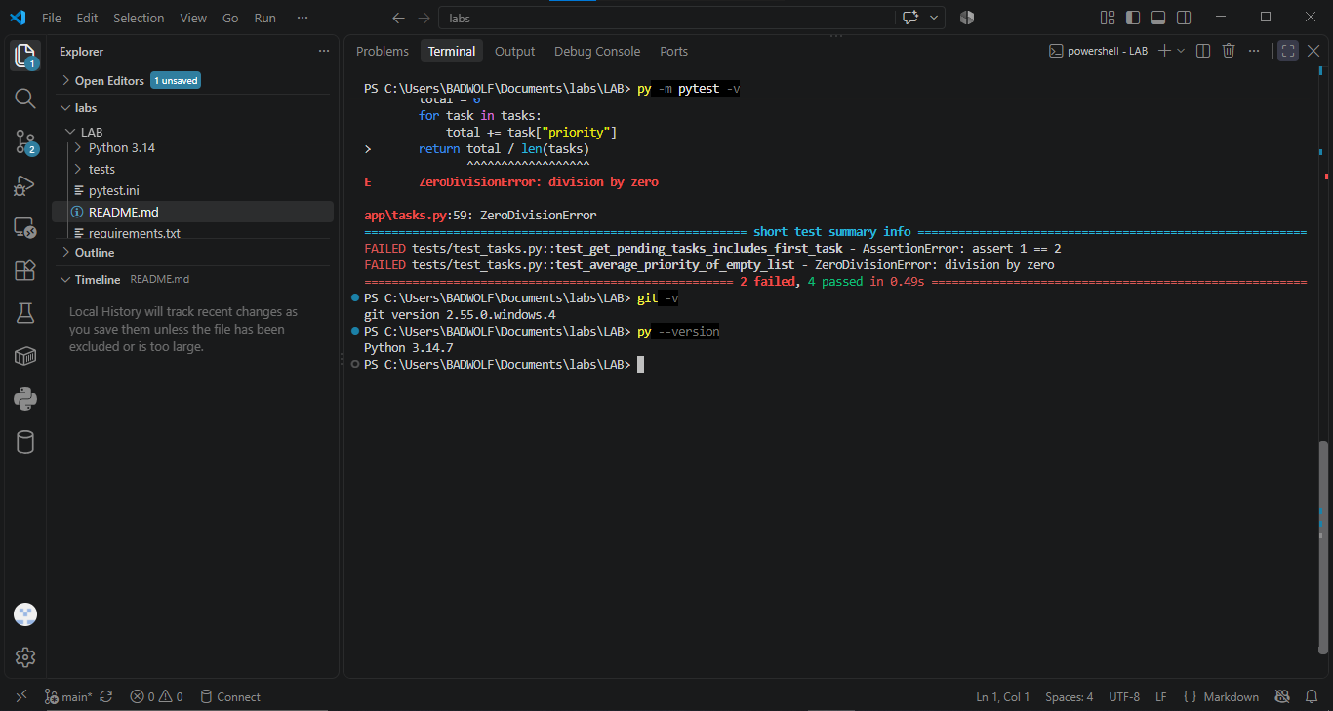
Picture showing git version,python version installed the test ran and how many were successful and how many failed.

LAB 2
TRIAGE TABLE
FINDINGS | SEVERITY | FIX EFFORT
Inconsistent return statements (tasks.py:62) | Medium | Low
File opened without with (tasks.py:11) | Medium | Low
Unused import save_tasks (cli.py:2 | Low | Low
Unnecessary else after return (tasks.py:79) | Low | Low
Unused import add_task (cli.py:2) | Low | Low

COMPARISON TABLE
Code snippet | Linter | Ai
def load_tasks():  """Load tasks from disk, returning an empty list if no file exists."""  if os.path.exists(TASKS_FILE):  f = open(TASKS_FILE, "r")  data = json.load(f)  return data  return [] | Unspecified encoding; not using with | Race condition between exists-check and open; no handling for corrupted/missing-file exceptions
from app.tasks import load_tasks, save_tasks, add_task, get_pending_tasks  from app.storage import format_task_report  def main():  tasks = load_tasks()  print("Loaded", len(tasks), "tasks")  print(format_task_report(tasks))  pending = get_pending_tasks(tasks)  print("Pending tasks:", len(pending)) | Missing docstring; 2 unused imports | Mixing I/O with logic (untestable design); no error handling for a crashing main()

3 PRIORITY FIXES
FINDING | BEFORE | AFTER | WHY THIS FIX
Dangerous default value tags=[] | def add_task(tasks, title, priority=1, tags=[]): | def add_task(tasks, title, priority=1, tags=None):  if tags is None:  tags = [] | The old code reused the same list for every task that didn't supply its own tags, so tags from one task could silently leak into another. The fix creates a brand-new empty list every single time the function runs, so tasks never share data by accident.
is_premium == True + unnecessary else | if is_premium == True:  return price * 0.8  else:  return price | if is_premium:  return price * 0.8  return price | is_premium is already True or False, so comparing it to True is redundant — like asking "is 'yes' equal to 'yes'?" instead of just checking the answer. The else was also pointless, since the,if already exits the function with return, so anything after it only ever runs in the "false" case anyway
Inconsistent return statements | for task in tasks:  if task["title"] == title:  return task  (implicitly returns None if nothing found) | for task in tasks:  if task["title"] == title:  return task  return None | Before, if no task matched, the function fell off the end and Python silently returned None on its own. Now that "no match" case is written out explicitly, so anyone reading the code can see what happens in every situation.

LINT REPORT BEFORE
************* Module app.cli
app\cli.py:6:0: C0116: Missing function or method docstring (missing-function-docstring)
app\cli.py:2:0: W0611: Unused save_tasks imported from app.tasks (unused-import)
app\cli.py:2:0: W0611: Unused add_task imported from app.tasks (unused-import)
************* Module app.storage
app\storage.py:4:39: W0511: TODO: move to env var before release (fixme)
************* Module app.tasks
app\tasks.py:11:12: W1514: Using open without explicitly specifying an encoding (unspecified-encoding)
app\tasks.py:11:12: R1732: Consider using 'with' for resource-allocating operations (consider-using-with)
app\tasks.py:19:9: W1514: Using open without explicitly specifying an encoding (unspecified-encoding)
app\tasks.py:23:0: W0102: Dangerous default value [] as argument (dangerous-default-value)
app\tasks.py:62:0: R1710: Either all return statements in a function should return an expression, or none of them should. (inconsistent-return-statements)
app\tasks.py:71:4: C0200: Consider using enumerate instead of iterating with range and len (consider-using-enumerate)
app\tasks.py:79:4: R1705: Unnecessary "else" after "return", remove the "else" and de-indent the code inside it (no-else-return)
app\tasks.py:79:7: C0121: Comparison 'is_premium == True' should be 'is_premium is True' if checking for the singleton value True, or 'is_premium' if testing for truthiness (singleton-comparison)

-----------------------------------
Your code has been rated at 8.33/10

LINT REPORT AFTER
app\tasks.py:11:12: W1514: Using open without explicitly specifying an encoding (unspecified-encoding)
app\tasks.py:11:12: R1732: Consider using 'with' for resource-allocating operations (consider-using-with)
app\tasks.py:19:9: W1514: Using open without explicitly specifying an encoding (unspecified-encoding)
app\tasks.py:74:4: C0200: Consider using enumerate instead of iterating with range and len (consider-using-enumerate)

------------------------------------------------------------------
Your code has been rated at 8.80/10 (previous run: 8.27/10, +0.53)

